M.A.M COLLEGE OG ENGINEERING

PROJECT NAME:
Streamlining Ticket Assignment for Efficient Support Operations

TEAM MEMBERS:

1.SUNIL KUMAR.S

2.AJAY.R

3.POOVARASAN.A

4.PRABHAKARAN.U

Streamlining Ticket Assignment for Efficient Support Operations
The automated ticket assignment system is designed to improve the efficiency of customer support operations in an organization. It ensures that every incoming support request (ticket) is automatically categorized and assigned to the most appropriate support team based on predefined rules such as issue type, urgency, and technical skill requirements. This significantly reduces manual work, speeds up response time, and enhances overall customer satisfaction.

Setting up ServiceNow Instance
- Sign up for a developer account on the ServiceNow Developer site: https://developer.servicenow.com
- After logging in, navigate to the “Personal Developer Instance” section.
- Click on “Request Instance” to create your own ServiceNow environment.
- Fill in the required details and submit the request.
- Once the instance is ready, you will receive the instance URL, username, and password via email.
- Log in to your ServiceNow instance using the provided credentials.
- After logging in, you can now begin configuring the platform to automate ticket routing and assignment.

Create Users

Open service now.

Click on All >> search for users

Select Users under system security

Click on new

Fill the following details to create a new user
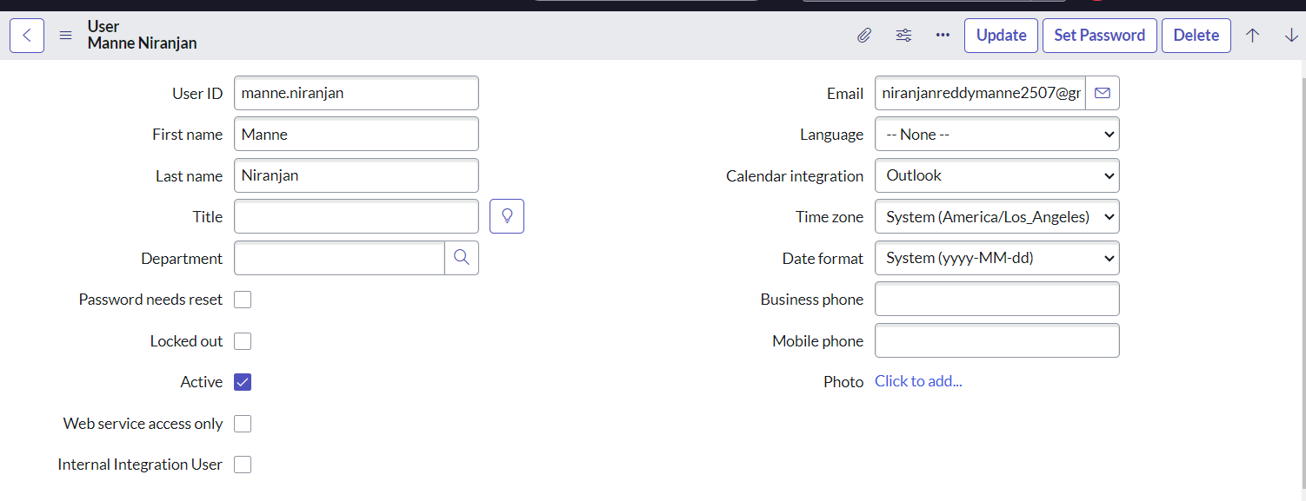

Click on submit
Create one more user:

Create another user with the following details
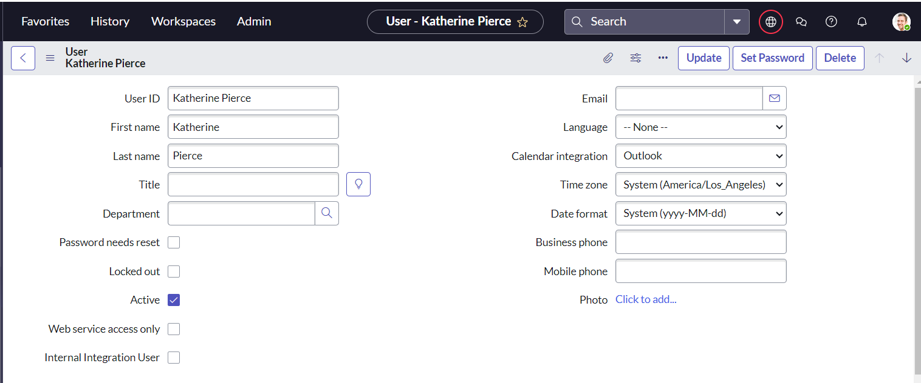

Click on submit

Create Groups

- Open service now.
- Click on All >> search for groups
- Select groups under system security
- Click on new
- Fill the following details to create a new group
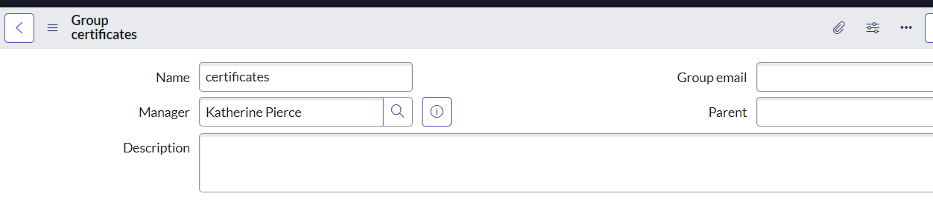
- Click on submit

Create one more group:

- Create another group with the following details
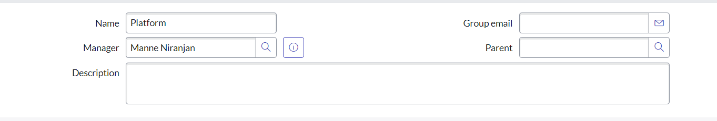
- Click on submit

Create Roles
- Open service now.
- Click on All >> search for roles
- Select roles under system security
- Click on new
- Fill the following details to create a new role
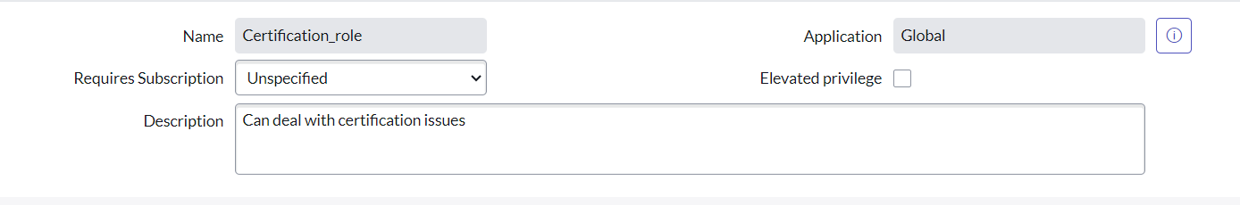
- Click on submit

Create one more role:

Create another role with the following details
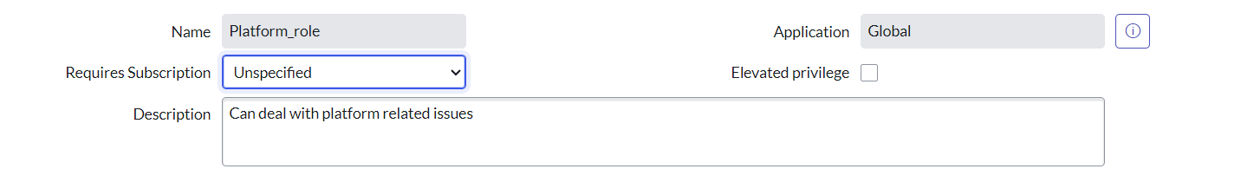
Click on submit

Create Table

  - Open service now.
  - Click on All >> search for tables
  - Select tables under system definition
  - Click on new
  - Fill the following details to create a new table
Label : Operations related
Check the boxes Create module & Create mobile module
  - Under new menu name : Operations related
  - Under table columns give the columns
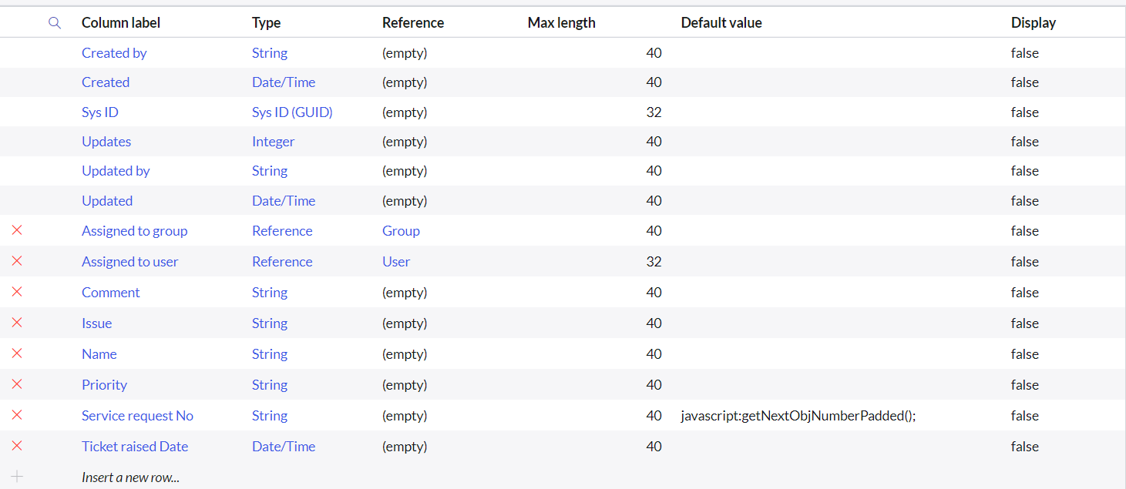
  - Click on submit

Create choices for the issue filed by using form design
Choices are
  - unable to login to platform
  - 404 error
  - regarding certificates
  - regarding user expired

Assign roles & users to certificate group
- Open service now.
- Click on All >> search for tables
- Select tables under system definition
- Select the certificates group
- Under group members
- Click on edit
- Select Katherine Pierce and save
- Click on roles
- Select Certification_role and save

Assign roles & users to platform group
- Open service now.
- Click on All >> search for tables
- Select tables under system definition
- Select the platform group
- Under group members
- Click on edit
- Select Manne Niranjan and save
- Click on roles
- Select Platform_role and save

Assign role to table
- Open service now.
- Click on All >> search for tables
- Select operations related table
- Click on the Application Access
- Click on u_operations_related read operation
- Click on the profile on top right side
- Click on elevate role
- Click on security admin and click on update
- Under Requires role
- Double click on insert a new row
- Give platform role
- And add certificate role
- Click on update
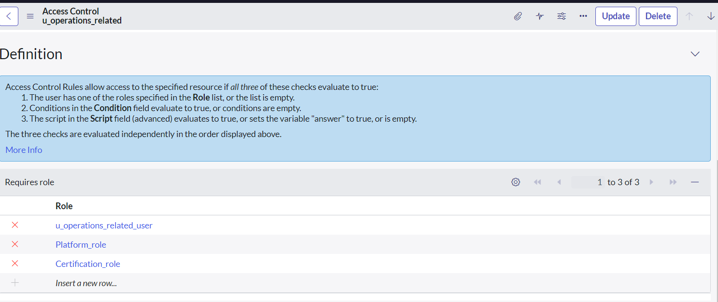
- Click on u_operations_related write operation
- Under Requires role
- Double click on insert a new row
- Give platform role
- And add certificate role

Create ACL
- Open service now.
- Click on All >> search for ACL
- Select Access Control(ACL) under system security
- Click on new
- Fill the following details to create a new ACL
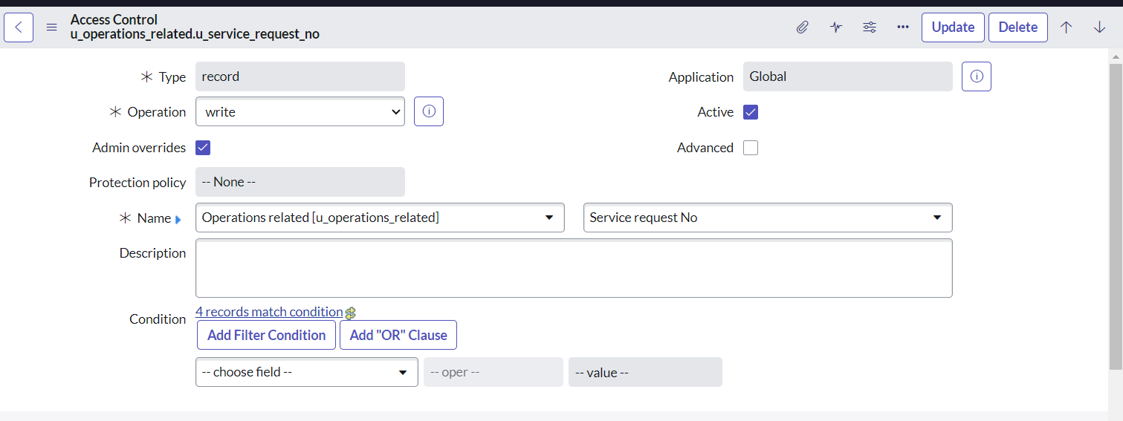
- Scroll down under requires role
- Double click on insert a new row
- Give admin role
- Click on submit
- Similarly create 4 acl for the following fields
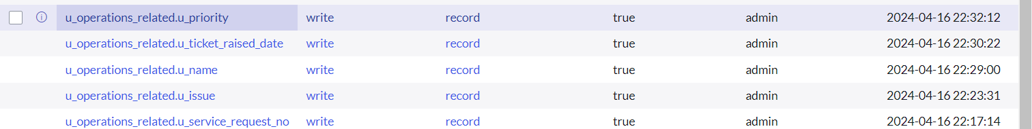

Create a Flow to Assign operations ticket to group

- Open service now.
- Click on All >> search for Flow Designer
- Click on Flow Designer under Process Automation.
- After opening Flow Designer Click on new and select Flow.
- Under Flow properties Give Flow Name as “ Regarding Certificate”.
- Application should be Global.
- Select Run user as “ System user ” from that choice.
- Click on Submit.
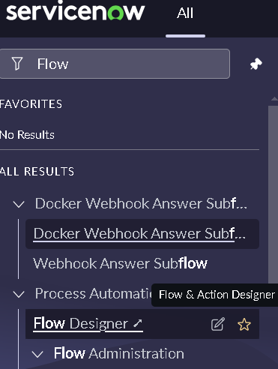
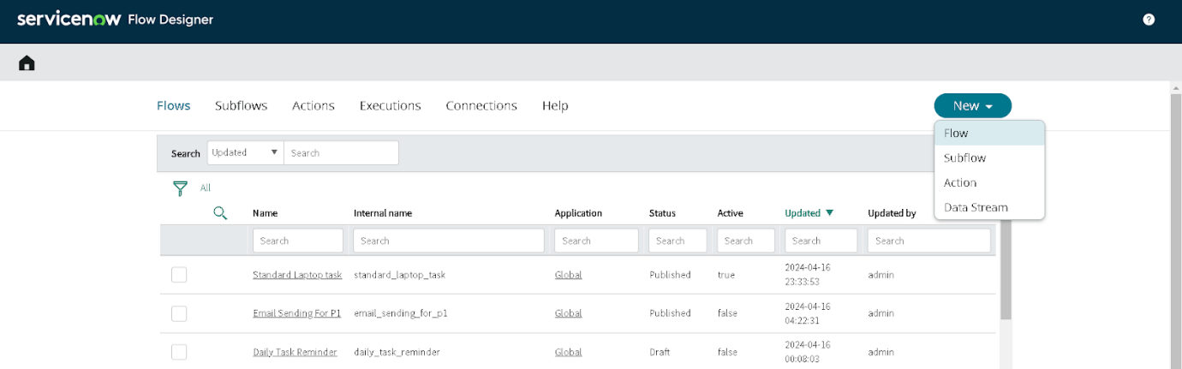
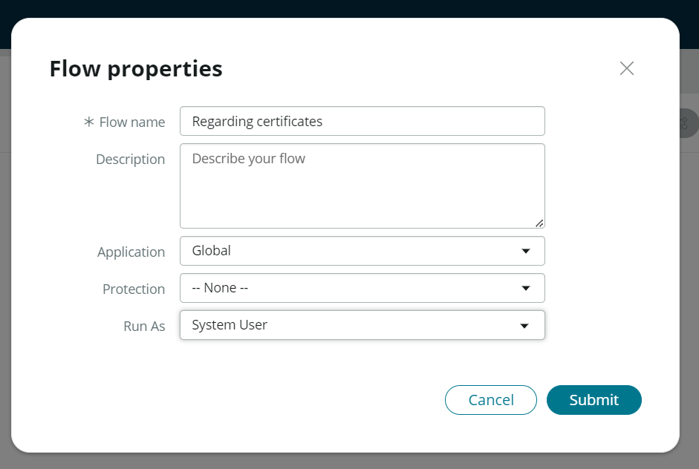

- Click on Add a trigger
- Select the trigger in that Search for “create or update a record” and select that.
- Give the table name as “ Operations related ”.
- Give the Condition as
Field : issue
Operator : is
Value : Regrading Certificates
- After that click on Done.
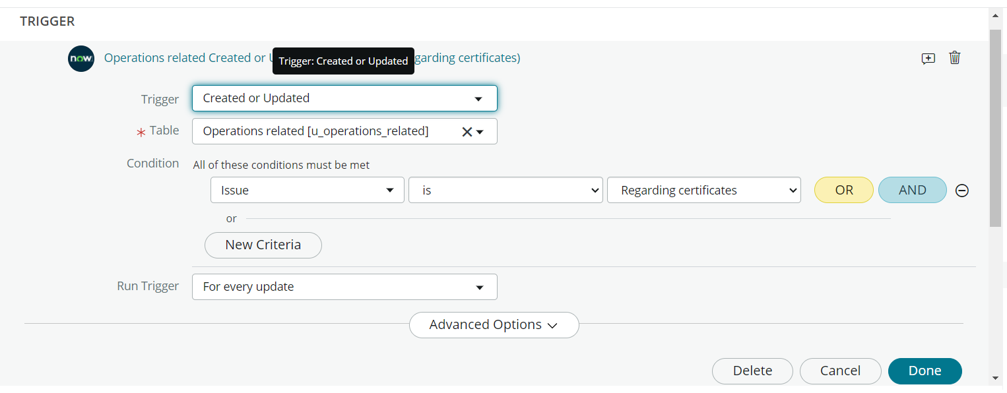
- Now under Actions.
- Click on Add an action.
- Select action in that search for “ Update Record ”.
- In Record field drag the fields from the data navigation from left side
- Table will be auto assigned after that
- Give the field as “ Assigned to group ”
- Give value as “ Certificates ”
- Click on Done.
- Click on Save to save the Flow.
- Click on Activate.
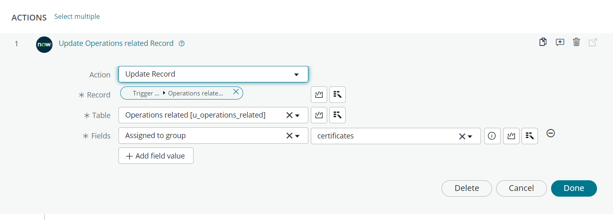

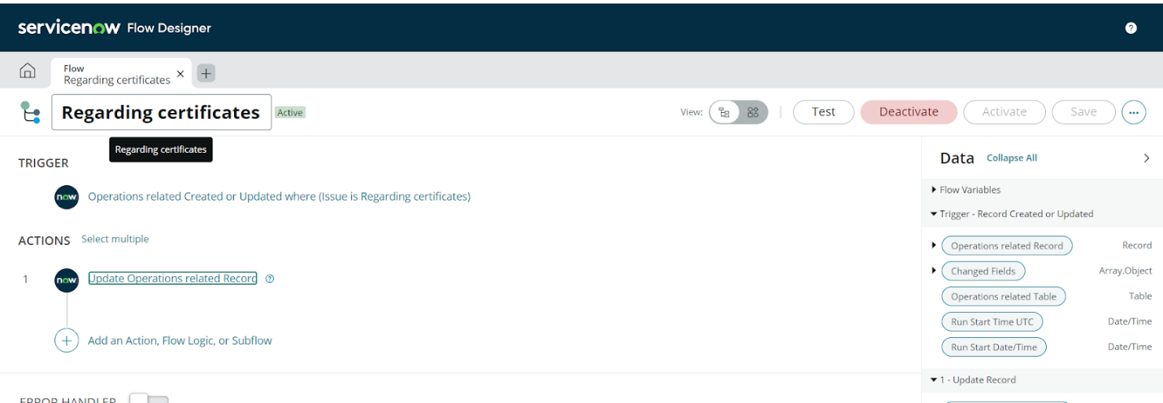

Create a Flow to Assign operations ticket to Platform group

- Open service now.
- Click on All >> search for Flow Designer
- Click on Flow Designer under Process Automation.
- After opening Flow Designer Click on new and select Flow.
- Under Flow properties Give Flow Name as “ Regarding Platform ”.
- Application should be Global.
- Select Run user as “ System user ” from that choice.
- Click on Submit.

- Click on Add a trigger
- Select the trigger in that Search for “create or update a record” and select that.
- Give the table name as “ Operations related ”.
- Give the Condition as
Field : issue
Operator : is
Value : Unable to login to platform

- Click on New Criteria
Field : issue
Operator : is
Value : 404 Error

- Click on New Criteria
Field : issue
Operator : is
Value : Regrading User expired

- After that click on Done.
- Now under Actions.
- Click on Add an action.
- Select action in that search for “ Update Record ”.
- In Record field drag the fields from the data navigation from left side
- Table will be auto assigned after that
- Give the field as “ Assigned to group ”.
- Give value as “ Platform ”.
- Click on Done.
- Click on Save to save the Flow.
- Click on Activate.

Conclusion
The implementation of the automated ticket routing system at ABC Corporation has been a significant success. By leveraging the capabilities of ServiceNow, we have streamlined the process of assigning support tickets to the appropriate teams, addressing the challenges of manual routing, and ensuring timely resolution of issues.

